**React Redux Saga - Tasks**

**Learning:** Goal is to learn the below mentioned concepts to get better understanding of React

1. DOM - Goal is to understand how DOM works and how to manipulate DOM elements

2. State - To learn state management

3. Props - To learn how to pass data from parent to child components

4. Components

5. React Component Lifecycle

**Task - 1: Counter Example**

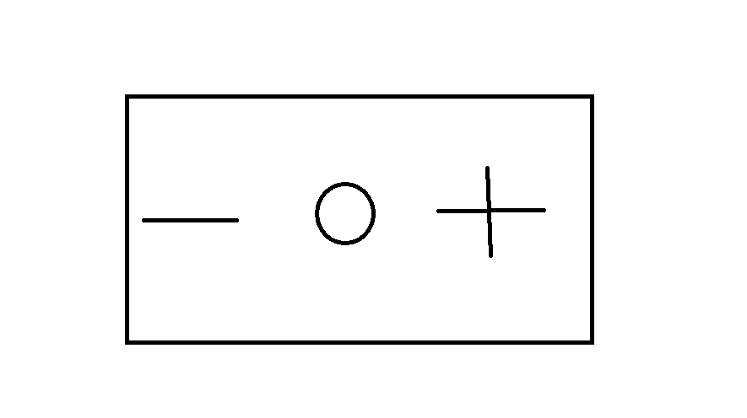

* Create a react counter using state management which updates the count value. The count should be increased when + is clicked and count should be reduced when - is clicked.
* The goal is to learn how to update count values based on state.

**Task - 2: Props Example**

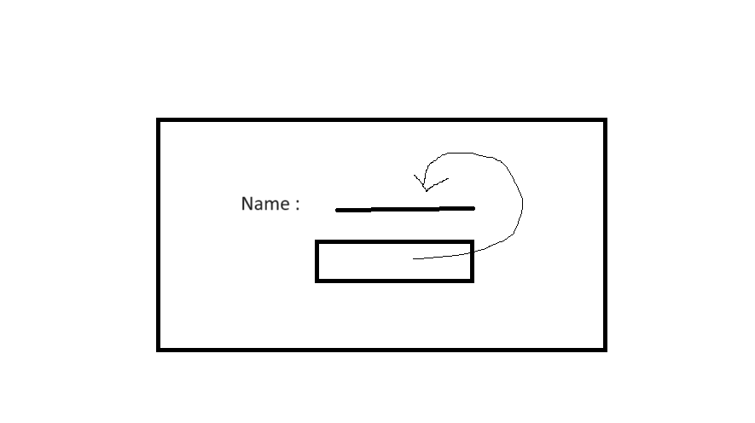

* Implement a props example that takes name as input in parent component and displays this name in child component.
* The main goal is to understand how to pass data from one component to another component.
* To learn the differences between props and state and when to use each.

**Task-3: Student Table in React.**

Implement the javascript student table task in react.

The goal is to learn how to break down the UI into manageable components. And to implement the dynamic student table

**Learning:** Read below concepts

1. What is React

2. Plain redux and why redux

3. What is prop drilling

4. Generators

5. What is Saga

6. Redux Saga Plain

**Task - 4: Counter Example in React-Redux**



* Implement the same counter example in Redux.
* The goal of this task is to learn how to set up a Redux store and connect it to a React application.
* How to manage state globally using Redux.
* Connecting React components to the Redux store to access and update state.

**Task -5: Context**

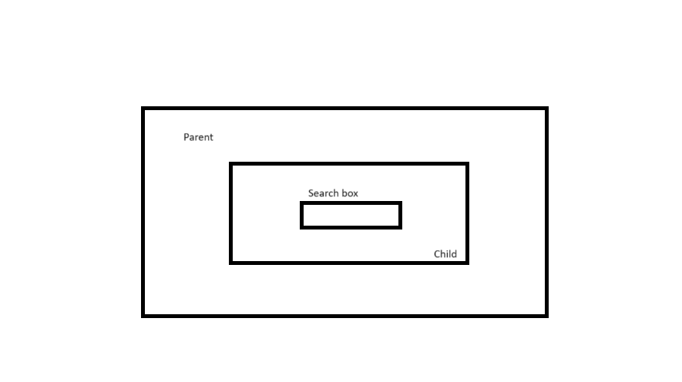

* Implement a props example which uses context in react.
* There should be a parent component and child component. In the parent component, there should be a search box or input field asking for a name. When the name is entered, it should be displayed in both the parent and child components.
* The goal of this task is to learn how to use context and callback value by passing.

**Task - 6: Student Table in Redux Saga**

Implement the same Student table task in Redux and Saga.

The goal of this task is to understand saga basics and middleware. How redux and saga can be linked with react.

**Task - 7: Router**

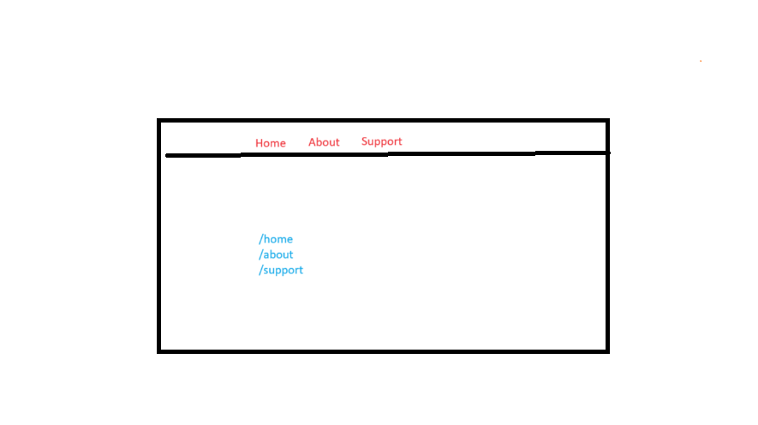

* Implement router examples in react and redux.
* The goal of this task is to learn how routing works and get understanding about routers.
* The task is to display a few buttons on the screen. When clicked on any button, they should be navigated to another page.
* Task should be implemented in React and Redux and should make use of actions, reducers, action types and store.

**Learning:** Learn the below concepts to get understanding about how website data is stored.

1. Local Storage
2. Session Storage
3. Cookies

**Task -8 : Website**

* The aim of the task is to create a perfect and industry standard UI only website which uses all the concepts learned upto now.
* Implement the website in React, Redux and Saga.
* Use all the concepts from react, redux and saga and incorporate them in the website accordingly